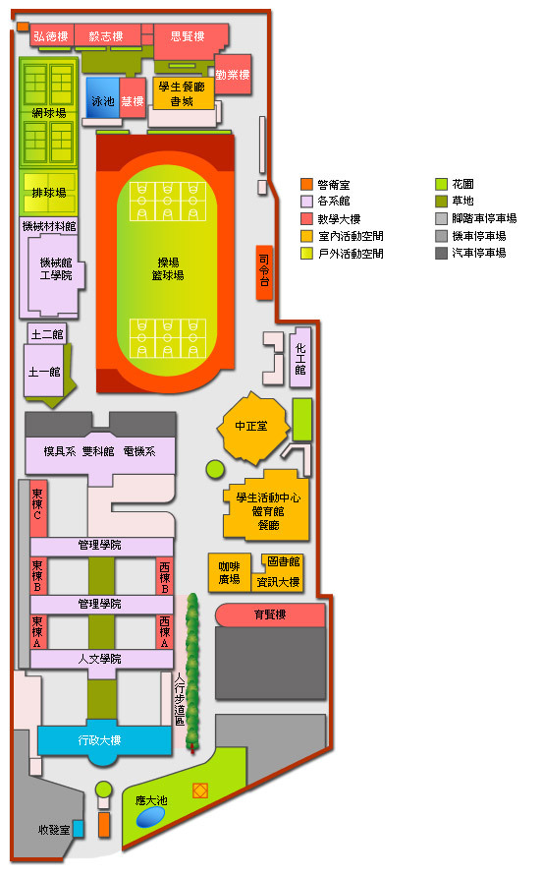

Entrance

(Jingoug Road)

**2016 KUAS**

**International Culture Festival**